

Practices for Secure Software Report

Table of Contents
Document Revision History 3
Client 3
Instructions 3
Developer 4
1. Algorithm Cipher 4
2. Certificate Generation 4
3. Deploy Cipher 4
4. Secure Communications 4
5. Secondary Testing 4
6. Functional Testing 4
7. Summary 4
8. Industry Standard Best Practices 4

Document Revision History

Version | Date | Author | Comments
1.0 | October 14, 2026 | Jason McDaniel

Client



Instructions

Submit this completed practices for secure software report. Replace the bracketed text with the relevant information. You must document your process for writing secure communications and refactoring code that complies with software security testing protocols.

- Respond to the steps outlined below and include your findings.
- Respond using your own words. You may also choose to include images or supporting materials. If you include them, make certain to insert them in all the relevant locations in the document.
- Refer to the Project Two Guidelines and Rubric for more detailed instructions about each section of the template.

Developer
Jason McDaniel

Algorithm Cipher

For Artemis Financial’s file verification feature, I suggest using SHA-256 as the checksum algorithm. SHA-256 is a cryptographic hash function in the SHA-2 family that converts data of any size into a fixed-length, 256-bit hash value, commonly represented as a 64-character hexadecimal string. The program can compute the SHA-256 hash of a transferred file and compare it to the hash produced by the received file. The file is probably unaltered if the values match; if they don’t it might have been tampered with or corrupted. SHA-256 is appropriate because it is collision-resistant, widely supported, and considered secure for integrity verification. It cannot be undone to retrieve the original file and does not employ encryption keys. However, SHA-256 provides integrity verification rather than confidentiality or authentication by itself. Artemis Financial should employ a secure transport protocol like TLS and take into consideration a keyed hash, like HMAC-SHA-256, for authentication in order to provide greater security against an attacker who could replace both the file and its checksum.

Certificate Generation
Insert a screenshot below of the CER file.

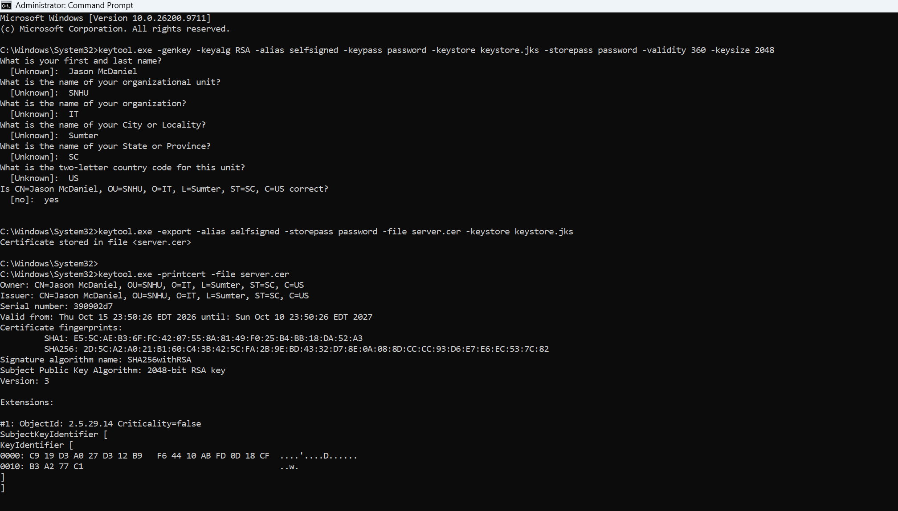

Deploy Cipher
Insert a screenshot below of the checksum verification.

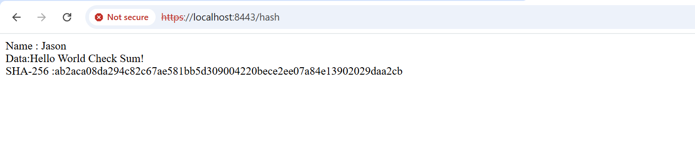

Secure Communications
Insert a screenshot below of the web browser that shows a secure webpage.

Secondary Testing
Insert screenshots below of the refactored code executed without errors and the dependency-check report.

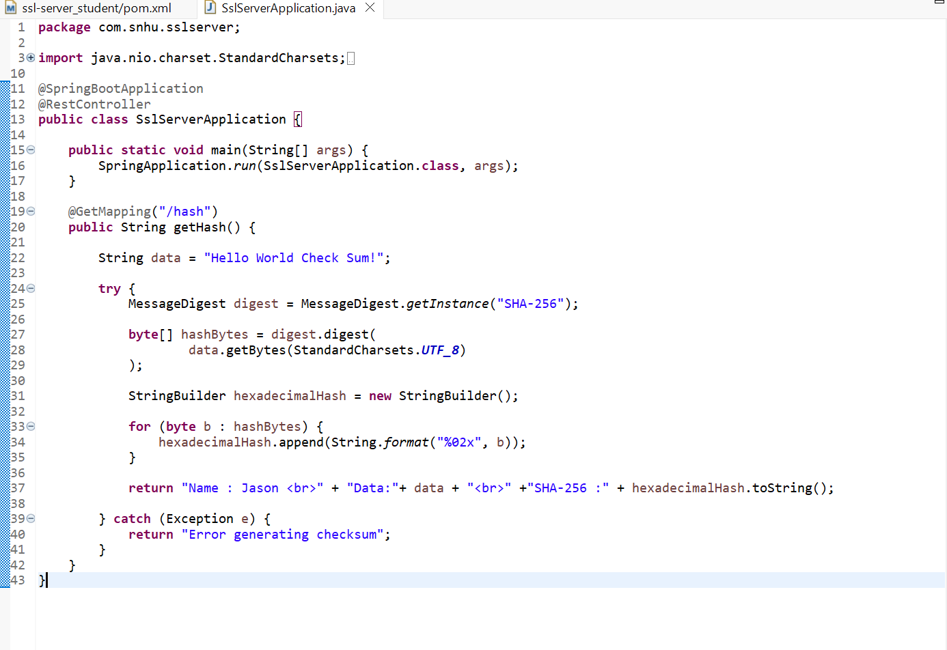
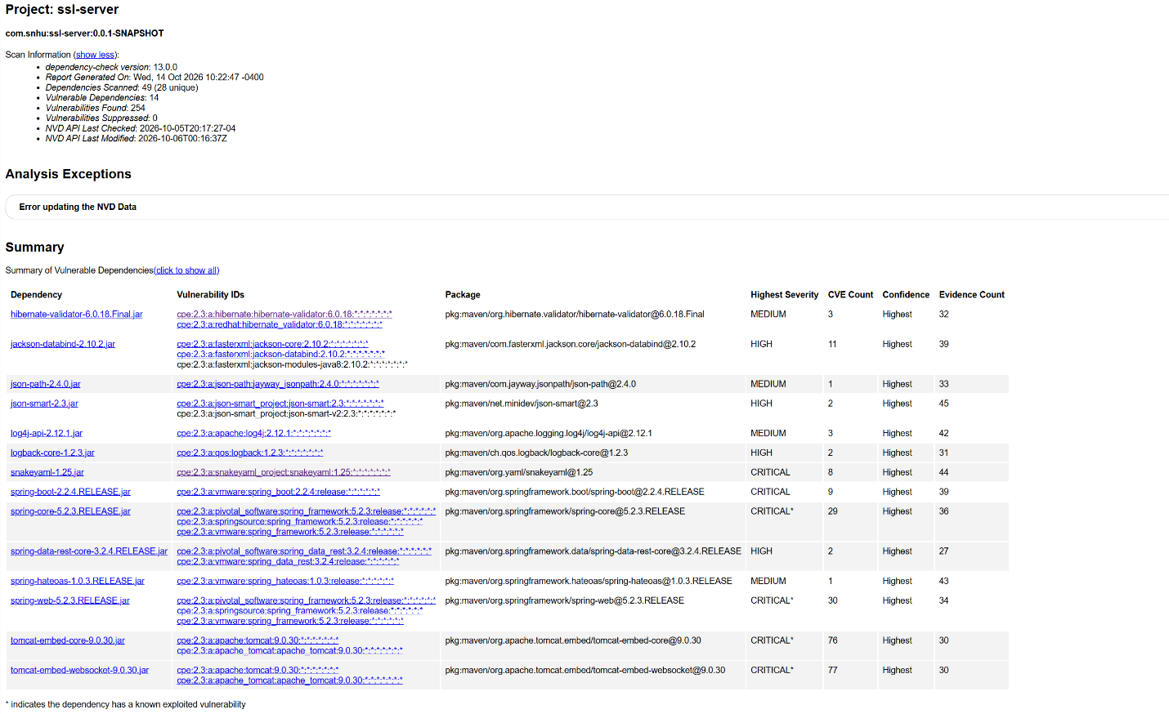

Functional Testing
Insert a screenshot below of the refactored code executed without errors.

Summary

A Spring Boot REST endpoint at ‘/hash’ that creates a SHA-256 hash for the given data was created by reworking the code. It avoids depending on the system’s default character set by using UTF-8 encoding and Java’s reliable ‘MessageDigest’ class, which encourages consistent output. The hash is converted to hexadecimal format so it can be easily displayed and verified. Important aspects of the vulnerability-assessment process are addressed by the refactoring, such as testability, regulated error handling, consistent data processing, and safe cryptographic implementation. The ‘try-catch’ block prevents technical error details from being exposed to users and returns a general error message instead. By integrating a reliable hashing library, specific character encoding, secure output formatting, and error handling, the program employs defense-in-depth. Because the hashing process is deterministic, it can be verified through unit, integration, and regression testing. SHA-256 provides data-integrity verification, but it is not encryption. Additional safeguards like HTTPS, authentication, input validation, dependency scanning, and secure response formatting should be put in place in a production setting.

Industry Standard Best Practices

Instead of developing a custom cryptographic implementation, industry-standard secure coding standards were implemented by utilizing Java’s built-in ‘MessageDigest’ library with the SHA-256 algorithm. The application also uses explicit UTF-8 encoding to ensure that data is processed consistently across systems. To protect consumers from sensitive technical information, such stack traces, exceptions are handled using a managed error message. These procedures lessen the possibility of cryptography, encoding, and information-disclosure vulnerabilities while preserving the application’s current security. Following secure coding standards benefits the company by reducing the likelihood of data breaches, system failures, and costly security defects. Reliable hashing helps protect data integrity, while consistent error handling limits information exposure. The program is also simpler to test, maintain, and audit when secure development standards are used. In the long term, these practices protect customer trust, support compliance with security requirements, reduce remediation costs, and improve the company’s overall security posture.

